# Instructions for Accessing Submission

*Table 2 Demonstration Access*

|  |  |
| --- | --- |
| Description | URL |
| 1. GreenSpace Demo | <http://107.23.132.208:8080/greenspace/> |
| 1. GreenSpace Mobile Demo | <http://107.23.132.208:8080/greenspace/web.html> |
| 1. NITF-MODIS App   AppSymphony Apps | <http://107.23.132.208:8080> |
| 1. Greenspace Video | <https://www.youtube.com/watch?v=zQJUX8vx1aw> |
| 1. NITF-MODIS Video | https://www.youtube.com/watch?v=C_Q05d-5N9M |
| 1. VegMonitor Video | <https://www.youtube.com/watch?v=Otw4hnXHA_Y> |

**App 1: Greenspace Instructions**

To access the demo, navigate to <http://107.23.132.208:8080/greenspace/> If you would also like to see how the application looks on a mobile device, navigate to <http://107.23.132.208:8080/greenspace/web.html> The application is currently fully functional on Android and iOS mobile devices, but we felt the fully functional browser based version would be easier logistically for evaluators of this challenge.

When you navigate to the demo, you will see a Google map interface as shown in the figure below. Depending on your privacy settings and browser, the map will either be centered on your current location or Washington, DC.

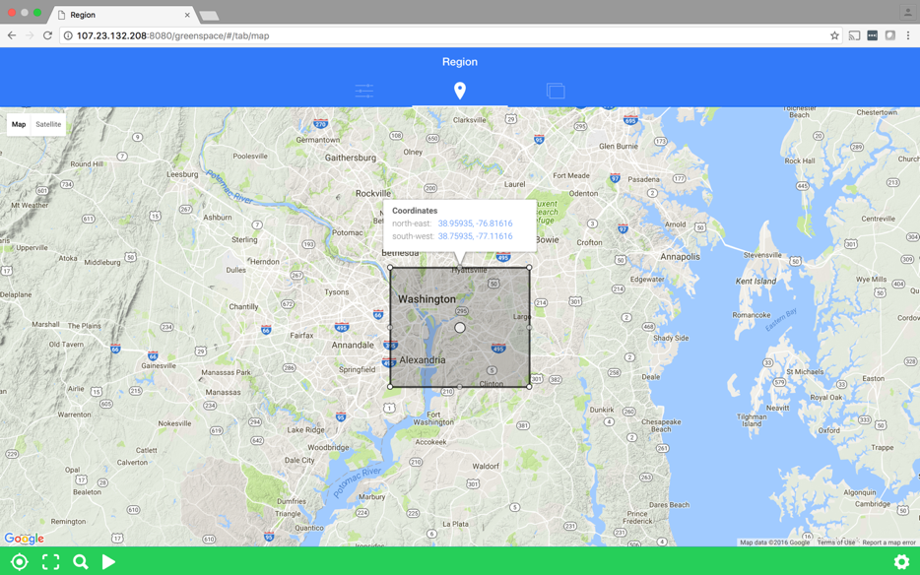

The application has three main tabs that can be accessed by clicking them as shown in the red oval in the next figure. The left tab (Indices) allows the user to specify one or more spectral indices to apply when searching for water content in the images. The center tab (Region) allows the user to specify the geographic region of interest and the right tab (Results) allows the user to view search results.

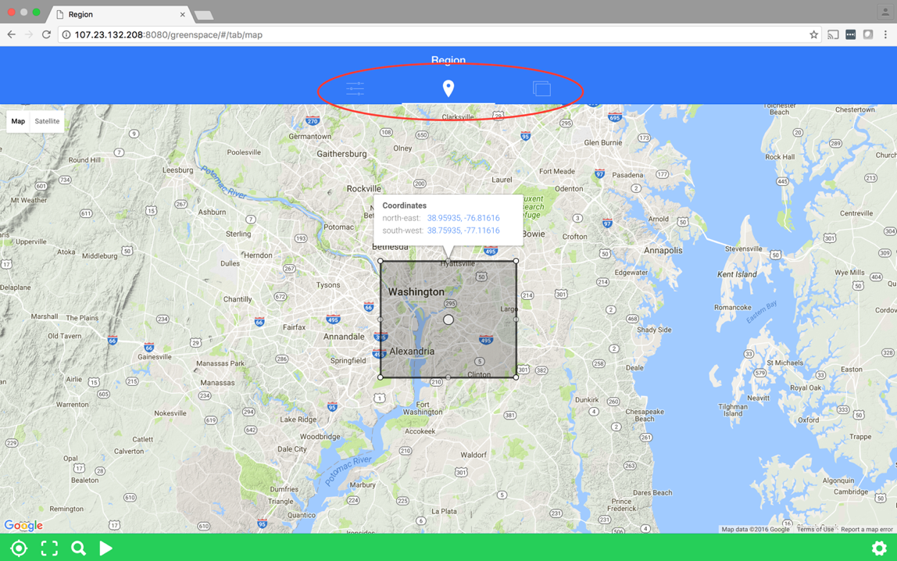

**Region Tab**

The region tab has four primary controls in the lower left corner. The furthest left is the geolocation button which will move the center of the map to the user’s current location (if privacy settings allow it). The next button will place a default query region in the center of the current map view. The third button will bring up a text box where the user can specify the region to center the map. The search box has auto-completion and provides an interface to the Google gazetteer functionality, but could be easily replaced to an official government authoritative gazetteer. The final button in that group will perform the query and populate the results tab.

**Indices Tab**

The indices tab allows a user to specify one or more spectral indices to apply to the data set when searching for water content.

**Results Tab**

The results tab provides the user with the most recently collected raw Landsat image of the geographic region as well as that image after the requested spectral indices have been applied. While the data retrieval is fast, the water content processing can take approximately 60 seconds before results are returned. The app is built to be asynchronous so the user can make other queries while waiting for the processing to return.

**App 2: NITF-MODIS Demonstration App Instructions**

We have provided a functional AppSymphony instance so you can run the NITF-MODIS Demonstration App yourself, as well as see the workflows that are powering the back end of the Greenspace app. To access AppSymphony navigate to <http://107.23.132.208:8080/>. AppSymphony is supported in a variety of browsers, but for the best experience we recommend Chrome Version 52 or higher.

To run the NITF-MODIS app:

1. Click on the APPS group  in the composer palette panel on the left to open up the list of AppSymphony apps.
2. Click and drag the NITF-MODIS Demo App  to the right onto the app ‘canvas’ to see the app diagram.
3. Click on the run arrow  in the button bar at the top
4. Click the Run button on the Execute dialog to run the app with the default NITF_URL.
5. Once the app start, click on the Jobs button on the far right side of the button bar to show the job status panel. While the app is running, you’ll see the animated execution widget in the Jobs panel.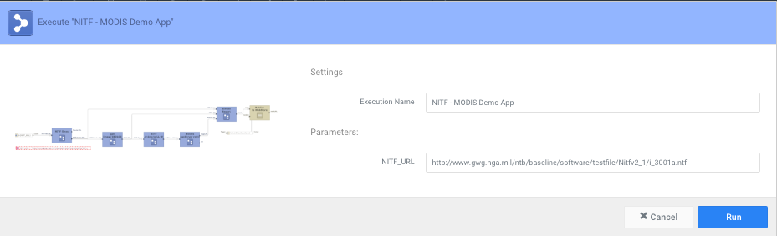



1. When the app finishes running, you’ll see the success completion widget.



1. Click on the completion widget to see the simple results report that the app generated. If you wish, you can copy the MODISURL into another browser window to see the retrieved MODIS image. Scroll down to see the the full file header and subheader header information that was extracted from NITF file.
2. Click on the X upper right to close the results report.

You may wish to run this app again with other NITF file URLs – simply enter the URL into the NITF_URL field in step 4 above. Keep in mind that at this time only NITF 2.1 files are supported. Also keep in mind that not all NITF files have IGEOLOC data in the first image segment subheader. In those cases, the app will report an error and terminate. You may click on the error completion widget to see that IGEOLOC data was not found in the NITF file.

**Viewing the AppSymphony Canvas – The ‘Back End’ App**

To see the AppSymphony app powering GreenSpace click on Apps and then click on the app named VegMonitor and drag it onto the screen. You can open any of the components by hovering over it and then clicking the green box above it as shown in this YouTube video (<https://www.youtube.com/watch?v=Otw4hnXHA_Y)>.

You can also click on any of the ensembles of components on the left hand side of the screen and see some of the base components that come with AppSymphony. You can drag and drop these components to the canvas to create an app.

We have disabled the ability to save additional apps or modify the existing apps on this AppSymphony instance because we have it publicly available without requiring a login to insure evaluators can easily access it. If you make any changes to the app (including cosmetic changes that change the layout of the components) you will have to reload the app before attempting to execute it because the save functionality is disabled.